Conserving Herefordshire’s Ice Age Ponds Project
Newsletter for Volunteers

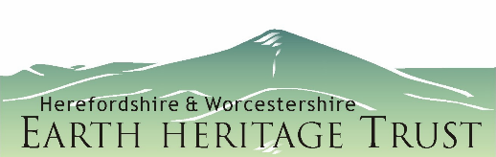
Dear Volunteer,
Thank you so much for supporting the project! We can’t do it without you.
With the project now approaching the end of its Development Stage (the application is due in by 20th August) here is a long overdue update by way of a thank you to those who have been spending time carrying out surveys with our Survey Team: Beth, Will and Giles.
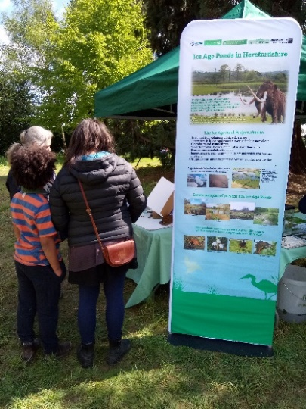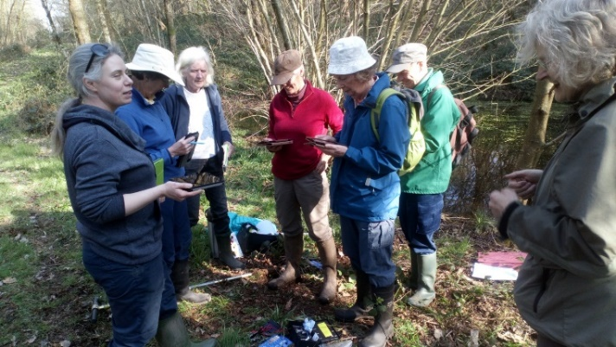
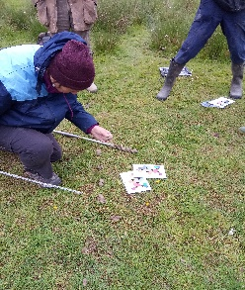
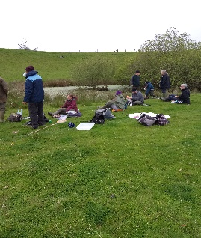

Achievements this year
One of our main achievements this year was to involve 57 people in Training Courses held on four dates at two venues. These provided an excellent introduction to the origins and ecology of kettle hole ponds in the county, and many of you came away with an enhanced knowledge and enthusiasm for finding out more about these amazing features. The feedback forms were very positive. Thank you!
So far, over 30 of you have come out on further survey days and are providing really useful information that will add to our knowledge about these ponds and become part of our application for further funding from the Lottery.
During the Development Stage, we have contacted landowners and managers of ponds that have been identified as potential Kettle Hole Ponds (KHPs) through previous surveys and through various public engagement events. We have over 30 ponds lined up for initial surveys and 15 of these will be the subject of more detailed surveys and management plans.
Mapping data from LiDar, current and historic Ordnance Survey maps, and aerial photographs have been incorporated into a GIS dataset and is now accessible for interrogation in order to confirm the geological and landform origins of the ponds.
As a result of this work, we have produced a ‘user friendly’ map, clearly showing the distribution of Kettle Hole moraine in the county. The map included in this document also has the location of those we are surveying this year.
This map has been used to great effect at the various events and festivals where project partners engaged with local audiences. People are able to use this map to locate ponds in their area and to engage in discussions about local geology and the likelihood of ponds being kettle holes.

Achievements so far thanks to the help and support of volunteers and staff from HWT, HART and HWEHT:
- we have delivered four talks to local groups on the origins and wildlife of KHPs
- led kettle hole pond themed guided walks (more are planned)
- We have attended seven public or community events and distributed KHP information and leaflets
- We held a stakeholder engagement meeting at Weobley on 20th June
- We have delivered talks to representatives of four parish councils
- We met with representatives from Herefordshire Council regarding our HLF application and our taking part in a planned ‘Ice Age Hereford’ exhibition at Hereford Museum early next year
- We received expressions of interest from 72 people wanting to come on the first four of our formal training courses
- We have trained 57 people to undertake KHP pond surveys. To date, over 30 of these have come out on survey training days (more are due to come out in June and July) to hone their survey skills and gain confidence in filling in the form and in recognising KHPs, their geomorphological characteristics, their flora and fauna.
- We have surveyed over half of our target 30 Kettle Hole ponds
- We have contacted landowners and managers of ponds throughout NW Herefordshire to seek permission to survey their ponds
- We have created a Conservation Plan and Strategy
- We carried out five Ice Age Pond-themed school visits including Assembly and HWT Wildplay activities
- We have shortlisted 15 ponds for survey and management
- We created a bespoke survey form for KHPs
- The Steering Group and Survey team travelled to Norfolk for a fact-finding excursion on pingos (ice age ponds in Norfolk)
- We have started the detailed surveys of 15 ponds and writing management plans and costing management operations during the development stage.

There is still plenty to do in addition to carrying out the surveys. The following list details the areas where additional volunteer help would be invaluable.

- Help staff the Ice Age Pond Gazebo, talk to people and share your knowledge. - -- - Sites will include Queenswood Country Park, dates to be arranged in July
- Help to distribute leaflets at local libraries or parish notice boards.
- Help the survey team to carry out pond surveys.
- Check your local area for likely Ice Age Ponds – we are still looking for ponds to survey next year if we are successful in getting funding. We are particularly looking for sites in the Weobley and Orleton area: see the map below (where there are no red stars!)
We would like to invite you all to a thank you get together on a date to be arranged in August. We’ll be sending out further updates soon.
Thank you again for all your support.
Very Best Wishes,
The Ice Age Pond Project Team

If you are interested in helping with any of the above, please contact, Dave Hutton.
d.hutton@herefordshirewt.co.uk
01432 356872 /07494 045012

And a big thank you to all those people who buy lottery tickets!
